Diary of Two Close Encounter Witnesses
by
Kenneth John Parsons

Intro

Sorting the Men from the Boys
My little intro here is what might be called a confessional rant: A couple of years ago, (after nearly two decades of active involvement in this subject), I suddenly came to realize something; that I had been wasting my time delving into pointless red herrings and sideshows, that were getting me nowhere fast; by “nowhere” I mean, as far as gathering evidence for the existence of aliens and UFO's was concerned; so I began digging into other areas of UFOlogy, and eventually, everything fell into place; at last came a major breakthrough!
Yup, looking back reminds me of just where I went wrong; such as putting my trust into widely publicized cases; such as the Kecksburg Crash, The Aztec Crash The Roswell Crash, (The 'Whatever' crash), Area 51, The Kenneth Arnold Sightings, Project Bluebook, (Project This, Project That), supposedly de-classified UFO Files, (with nearly every line on them conveniently blacked out), The FOIA, (Freedom of Information Act), leaked documents etc etc; none of this ever led to anything substantial, and was/is in my opinion, a sheer waste of time; the armchair fantasy-side of things; the kind of presentations that people of a certain mindset feel most at ease with: You know the sort, they who like to THINK they know everything, but in actuality, know very, very little at all; they talk-the-talk, but fail to walk-the-walk.

I wonder how many of you reading these words will fall into the above category? Not too many I hope, but that doesn't matter anyway; because by now, anyone of that ilk would not have progressed beyond the first paragraph; they will have stopped, rolled their eyes, moved onto another distraction, and reverted back into their usual 'safe' mode way of thinking.

At UFO conferences you see them, the blinkered ones as I call them; they willingly sit through speakers who are simply promoting their latest publication, and/or on some kind of ego trip; in reality, numerous people go through all of this nonsense, merely in order to socialize afterward and shell out for an overpriced book or two; but as I suggested, cosy and safe is the way some folk tend to like things in this subject; and I am willing to bet hard cash, if that type were ever confronted by the REAL truth, the hard, nitty gritty about UFO's, and have their psychological comfort zone removed, I guarantee they would run a mile.

So many out there view Ufology as a part time, novelty pursuit; but at BEAMS we have no room for part timers; we need SERIOUS researchers, those willing to get their hands dirty; because now for the first time, we are dealing with a verified and ongoing case of supreme importance, involving UFO landings and actual alien contact.
Now down to business,... this superb series of close encounters involving alien contact with humans and some extremely exotic technology; a fine example of how persistence, experience and dedication have come into good effect for two men.

The Log

“It was a wonderful craft, and the beings in it were so loving, I wish you both could have been there with us that night, you would of had all your questions answered Ken.” Witness ‘H’.

The main focus of my report is a relatively unknown case,... a case which has until now, largely escaped the attentions of the UFOlogical world; yes, over the decades there have been others of a vaguely similar category, but few if any, compare to the quality of this one.

This is basically a log of two seasoned UFO researchers, turned contactees,... ‘H’ and ‘S’, (as they wish to be called), and later on we draw our conclusions; the sources include personal experiences and photographic evidence: This is not a work of creative writing but rather, a faithful account of some very REAL happenings.

I really cannot emphasis enough the veracity of these witnesses; they are good, down-to-earth, trustworthy, humble, (rather shy), family friends of ours, aged 60+ , and who have little in the way of technical knowledge when it comes to computers and cameras.

These are people who, (like myself, and other dedicated researchers), could be out in the field at up to 4am, in some unusual, remote spots, waiting for an opportunity to photographically capture strange phenomena; that might sound a little eccentric to those who do not appreciate exactly what we are trying to achieve, but I am afraid these types of extremes and sacrifices are sometimes what it takes to secure the best evidence.

As with myself, they seek no payment or publicity, and ask only that we moderate as regard personal names and encounter location specifics; soon the reader will realize why this has been done.

The Hampshire Garden Encounter

Witness 'H' has had numerous alien experiences down the years; night visitations and actual abductions, usually when he was asleep,... leaving only vague recall, and body marks behind, as proof that these were real happenings and not dreams.

He even saw structured UFO’s as well, and photographed them when he could, but always, these were objects frustratingly way off at a distance, (high altitude etc), and grainy, to be classed as intangible evidence.

However, April 13, 2011, saw a big turnaround for him.

At a location in Hampshire, United Kingdom, he rose from bed at about 9AM, and went to his window; there he was astounded to see an unusual, dark object, just hanging in the sky; hurriedly pulling on some clothes and grabbing his camera, he first took a photo through the glass pane, and then went outside.
Oddly, as soon as ‘H’ stepped out of the door he noticed how unusually quiet it was; although there is a side road through his estate, he could hear no traffic noise, as normally would be the case; none of the typical hustle and bustle, with people going to work, or to the shops etc; not even any twittering birds or the usual activity from neighboring houses, all he could hear was a feint whining noise in the air, (presumably from the strange aerial object), and nothing else.

After this, he finds it difficult to remember certain details, but clearly recalls rushing across the garden and firing-off about 100 shots from his Fuji Fine Pix S1730, 18MB automatic SLR digital camera, (the type where, if you keep your finger on the shoot button it will take pictures continuously), and moving about, attempting to keep the UFO, (which was at some height, but gradually descending), in his camera's viewing screen. (original photo above)
Another thing that stuck in his mind, was the memory of him going indoors after the UFO encounter,... which had begun just after 9am, and then looking at the clock when he went back in, only to see that the time was 12 noon! He had definitely lost a couple of hours unaccountably, and feels that he was abducted during this period.
The people that he shares the house with were out at work when all of this was going on, but as soon as they arrived back home, he told them everything that had happened; they were slightly disbelieving at first, but came to be fascinated, and only too sorry that they had missed this dramatic happening.
When he went to bed that night following the encounter, he had an extremely restless sleep and felt very ill the next day.
He then went into an all encompassing period of feeling very low and unhappy about his life.
Believing that he had somehow attracted unwelcome phenomena to the family home, a few weeks after this episode he left, and moved to another town where he rented a flat.
I kept in touch with him and later continued with the interviews by email, which he didn't mind.
Since that time, he had more alien experiences in his new place, together with a few flashbacks, which he kindly recounted for me: Harking back to his April garden encounter, it seems that the UFO craft, (which was initially very large when seen in the sky), shrank in size, and came right down into the garden and car park area at the rear of their house; apparently it kept changing shape; one moment it was like a trilby-hat, next a spinning top,… then a flattened disc!
When asked how the craft departed, the witness described it shrinking down further in size to virtually nothing, and disappearing like a “popping balloon”; from what we can gather, in a split-second it changed from something substantial, to an object the size of a walnut, then a dot, and then gone altogether!
I asked ‘H’ during one interview what he thought it was all about, regarding the aliens' intent and why they seem to have chosen him; he replied, “all I know is that it has something to do with a genetics program, and the years 2012 to 2016,... the time in between these dates”.
I pressed him on how he thought that 'they' operated, their shape-shifting capabilities etc, and he suggested that from his experience they were able to manipulate time and space, and that the aliens traveled “dimensionally”.
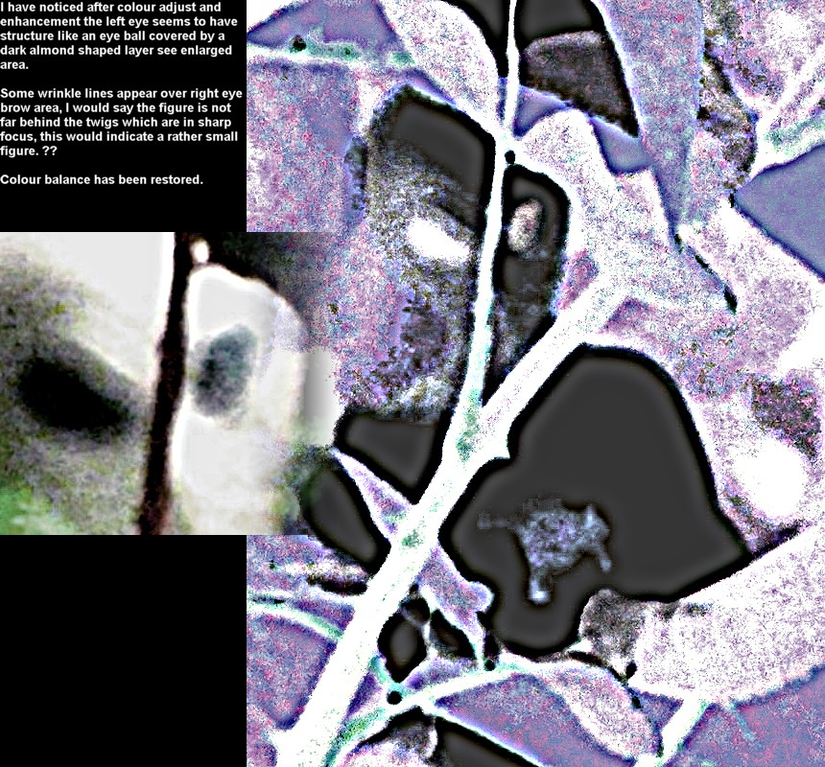
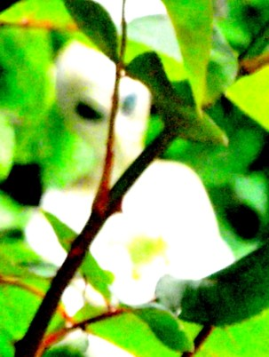
Bonus: Witness 'H' was going through his memory card, and amongst the UFO pictures, he found a jpeg of a small being!
At first we thought, surely this can't be, and that it was just his garden bushes and a trick of the light: but no excuses, clearly something is standing there, beyond any doubt: In fact, further analysis revealed pupils in the creatures' eyes. (look at image to left).
As the reader will see, the figure, (original image above top right), is white in color, and after in-depth examination, we all considered it to be fairly benign-looking; but as the old adage goes, appearances can be deceptive, and we have since learned that these creatures can actually cause us various degrees of harm).
We even wondered whether this alien had camouflaged itself among the leaves, perhaps to avoid detection? Perhaps they possess Chameleon-like abilities, where they can blend in with their surroundings?
‘H’ can’t remember seeing this creature or taking the photo, but nevertheless it is there, and many who have studied this have considered the possibility that somehow, the image was projected onto his camera as 'proof' to show doubters, or maybe even as a ‘present’ from these visitors.
Terror at Uffington in Late May

Just a handful of weeks later after the first move, witness ‘H’ left his 'new' flat to live at his friend’s house up in Oxford, UK.

The main reason for this move was to try and escape his recent CE4’s; for those who are unfamiliar with this term, a CE4 or a Close Encounter of the Fourth Kind, is where a human is abducted by a UFO or its occupants.

Unfortunately for him, (but fortunately for us though, as an investigative concern), wherever he went, the Aliens and UFO’s simply followed; and the reports kept coming.

It was now nearing the end of May, and ‘S’, (who is a trusted family friend of witness ‘H’), had taken delivery of a new car, so he told his pal that the old vehicle was his if he wanted it.

‘H’ gratefully accepted the offer and later, ‘S’ drove the it to Oxford for him, and told ‘H’ that he could have the car there and then, but he would need to take ‘S’ home that evening and drive back on his own.

Whilst he was delivering the car, ‘S’ decided that the two of them could take a bit of a tour around the area.

‘S’ thought that a day out in the fresh air would help ‘H’ forget his problems.

The two journeyed out to Dragon Hill, Uffington, which is noted for its famous hillside figure of the White Horse, and the nearby Wayland’s Smithy, Neolithic long barrow and chamber tomb site: Oddly, ‘S’ later told me, that this is the very place which he had a premonition about years previously; a forewarning which contained details about UFO activity there.

They got to the ‘Hill’ at about 5pm, and ‘S’ had his camera at the ready to take some photos of the views at Uffington, when suddenly he saw a black object going in and out of the clouds; he immediately told his friend who looked, and said that he could see it too.

‘H’ took his camera and began photographing the object, as did ‘S’

No sooner had their cameras begun firing, then this object just “dropped down” out of the sky, becoming bigger and bigger as it descended at rapid speed;

This was a huge black disc, (“as big a quarter of a football field” was the description), which, as he took photo after photo of this thing, caused ‘S’ to fall over and hurt his back.

The object rapidly stopped at about 10 meters or so above the pair and hovered, casting it's dark shadow over them. (just one image from the sequence shown below left)
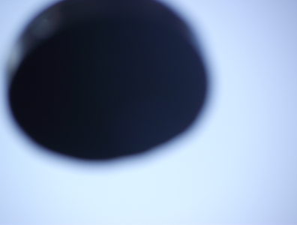

‘S’ staggered to his feet and gingerly looked above them for the object, then breathed a sigh of relief to see that it had gone; recollections again became a bit vague around this point, but the next thing he remembered was seeing ‘H’ laying down near him, and the surprise when he looked at his watch, to see that it was now 9pm! (Where had all of that time gone, between 5 and 9?, he wondered).

They were both in a dazed, confused and terrified state: Next ‘S’ recalls picking his friend up, helping him into the car and taking him to his mates house where he was staying…which although not that far in traveling terms, was, in his own words, “the longest drive I have ever had to make in my life!”

After helping out as much as he could, ‘S’ changed his plans, and left ‘H’ there in the safe hands of his other friend, took the car and drove back down South to be with his family; but he swiftly returned to Oxford next day to see how ‘H’ was doing.

Upon his return things were not looking good; it was discovered that large burn-type marks had appeared on the arms and forehead of ‘H’, and there were large scratches on his back, as if he had been dragged: He wasn’t himself that’s for sure,… he even looked different somehow, as if the experience had aged him about 10 years!

Luckily, most of the marks faded away after a few days, but at the time, these worried all concerned; the fear was that ‘H’ might have been struck by radiation from the object.

Gradually though, his health began to return, and he was on his way to a full physical recovery; the mental scars however, remained.

The only apparent injury to ‘S’ was a bruised back, (presumably from his fall), and quite bad peeling skin on his hands, which he thinks was the result of a brown sticky substance that he noticed on his fingers just after the craft encounter.

“S’ says, “I think about what happened every day, and wished you could have been there to see it Ken, how the craft dropped down out from the sky so fast, it was very frightening and I can see why ‘H’ is so petrified of this UFO returning.” “I thought it was going to flatten like a pancake us at one point.” he quipped”.

After this, ‘H’ and ‘S’ went their separate ways.

‘S’ told me that, just after the Uffington incident, he started getting weird emails and telephone calls in the middle of the night, and when either ‘S’ or his wife got to the phone, there was no one there; ‘S’ said “I was even receiving them at work and when someone would come and find me, and I got to the phone, they hung up”, which again just added more pressure to an already tense situation.

Many weeks after the Uffington case, ‘H’ was still seeing UFO’s and filming them in Oxford, so he decided that it was time to take a Summer vacation down in Somerset to try and overcome his ordeals.

Missing in Oxford, July.

Escape seemed impossible at times.

One evening in mid July, 2011, and nearing the end of his holiday, ‘H’ decided to explore some of Exmoor, and this is where he sighted a massive, illuminated, blue craft hovering in the air; thankfully he managed to video and digitally photograph the glowing object, which at one point released a dazzling, silvery beam of light down to the ground as he watched.

Later, he returned to where he was staying and went straight to bed, tired but apparently unharmed.

The holiday then came to an end and he traveled back to his friend’s house in Oxford:

Next day, he mentioned that he was just “popping down to the shops”…yet he never returned home; his car was later found abandoned at a nearby shopping center, but no trace of ‘H’.

After many days had passed without any indication of where ‘H’ could be, his friend informed the Police; but despite making inquiries from many quarters, no new leads were found.

A few weeks on and ‘H’ suddenly returned; he said sorry for all of the stress and concern he had caused, but after his last major UFO sighting he felt how his head had been “done in”, and he journeyed by train, down south, to stay with his auntie.

In fact, he later confessed that he has no “auntie down south” as he first claimed, and this had been a story that he had invented to appease people such as the police who had been searching for him, and to stop them worrying; later hypnotic regression revealed a different and more terrifying account of where he had been.

August-December 2011 (Update)

Since the time of the aforementioned experiences ‘H’ has returned to his original home, with ‘S’ and his family.

He has had numerous contacts with the alien craft, and steadily established several rendezvous points where he can study and film the visitors on their terms, (in other words, at irregular intervals, and when they feel it is the right time to make an appearance, and then 'H' is telepathically instructed where and when): The limitations to which he can work by are again, on the aliens' terms; usually filming from reasonable distance, and only rarely is he allowed on their ships.

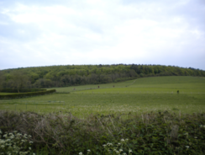
The locations are always rural spots, farm fields etc, little used places, and their showings are usually made at very unsociable hours; naturally, the whereabouts of these sites are kept secret for security reasons; we desperately want the phenomena to continue and not frighten the UFO’s away by unwelcome onlookers.

Late one evening, on the run-up to Christmas, 2011, the witnesses ventured out to go sky watching at one of their favorite locations; almost upon their arrival they noticed a bright, white light shining from within some nearby woodlands, something that they had never noticed there before.

Curious to see what it was, the pair walked towards the outskirts of these woods, and began weaving their way through the tangle of trees and undergrowth, all the while, their eyes fixed on the light source.

They neared the spot and looked-on in amazement: there, sitting in a sizeable firebreak, (a clearing created to slow or stop the progress of wildfires), which they never even previously known about,
was a luminous craft, compact in size, maybe only about 18 feet across.

At first, filled with trepidation and wonder, they cautiously watched from a distance, without actually stepping into the clearing.
Without warning or sound, the side of the craft suddenly opened; H' and 'S' were agog.

The witnesses were most specific about this point; it was not a door, rather it was the entire side of the alien vehicle that opened up, just like an envelope, exposing the inside as it did so: Unlike it's brightly glowing outer, the interior had a diffused light.

Next, two ‘human-like beings emerged from the glowing craft, a man and a woman, (just over 6ft in height), in a blaze of white light. (H & S are unsure whether the beings walked or floated along, as their feet were obscured in the radiance.)

Transfixed with wonder, yet mindful of possible danger, the witnesses were frozen to the spot by a mixture of emotions; yet as the beings approached, any fears they had quickly dissipated; the humanoids went right up to the witnesses and telepathically addressed them by their first names in a stern manner; 'H' and 'S' both heard these voices in their heads very loudly.

The beings ordered that 'H' should go with them, which he did quite willingly, leaving 'S' to record some of the situation as best as he could with his camera.
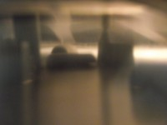
Without wanting to get too close, 'S' squinted right into the gloomy, shadowy heart of the vessel, and began to see two other types of figure; firstly, he could make out something resembling a praying mantis, (long neck, small head), which went and stood behind what was assumed to be, some sort of control console; then he noticed a smaller “monkey” creature sitting in a chair. There was different items of furniture present, but bizarrely, everything floated slightly off the extremely shiny and reflective floor. (right image)

Just why the photo's came out in this sepia fashion, we don't know, but it could have something to do with an energy field, that we suspect is generated by the craft.
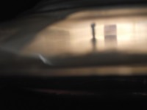
The witnesses told me of feeling that they were in a very dreamlike scenario at the time,... as these fascinating photographs confirm.

After 'H' and his escorts entered, the sides of the craft closed together again; 'S' noticed that there was a slight translucence to that portion of the hull where the opening had been, and the interior was still vaguely discernible; 'S' waited nervously for his friend to be returned, and whilst standing there he took the opportunity photograph around outside of the object.

We have pictures like this one (seen above right, which is an external shot of the 'landed' craft), and have learned quite a lot from them; for instance, a close examination of the photographic data confirms that the UFO is structured from a shiny material, best described as a cross between glass and metal, and indeed had an electrical energy about it.

Some weeks after this took place, I asked 'H' by email, exactly how the beings went back into the craft,... EG: whether they simply walked up a ramp, or were they beamed into the ship perhaps? this is his somewhat sketchy reply, (edited for security reasons).

“Yes Ken, there were beings at the windows on the craft; the man and women that me and ‘S’ talked to came out of the craft in a big white light and went back the same way; this light formed a mist around us; it was weird and a bit frightening, but when the beings started to talk we were fine with them... and they went back into the white light with the mist, and then the craft left.”

Me and ‘S’ got out of the woods and returned back to our car; we went back the next day after watching the footage, but we could not find the exact place where this had happened in the woods; we looked all over those woods; we had words over it, ‘S’ saying "this is it", and me saying "no, that is not the place",... so we just gave up looking, but it really happened.

Just imagine if the reader was put in a similar situation,... how would their brain have coped with such an ordeal? Personally, if it was me, I think I would probably be a jabbering wreck afterward, so it is understandable that their exact recollections are a patchy to say the least.

It transpires from other interviews I have conducted with these witnesses, that the entities were wearing boiler-like suits, the precise color of which cannot be agreed upon between ‘H’ and ‘S’; with one of the opinion that the suit material was dark green, the other saying possibly it was silver,… an uncertainty which is hardly surprising, considering how dark it was at that time of evening; another revelation was concerning the craft's inner proportions; basically, from all accounts, we can deduce that it was far more spacious on the inside than it seemed from the outside.

These aliens always spoke telepathically and addressed the witnesses very formerly, saying at the end that they were leaving, but they would return one day.

Upon hearing of their imminent departure, ‘H’ broke down and wept uncontrollably.

‘H’ added: “It was a wonderful craft, and the beings in it were so loving, I wish you both could have been there with us that night, you would of had all your questions answered Ken.”
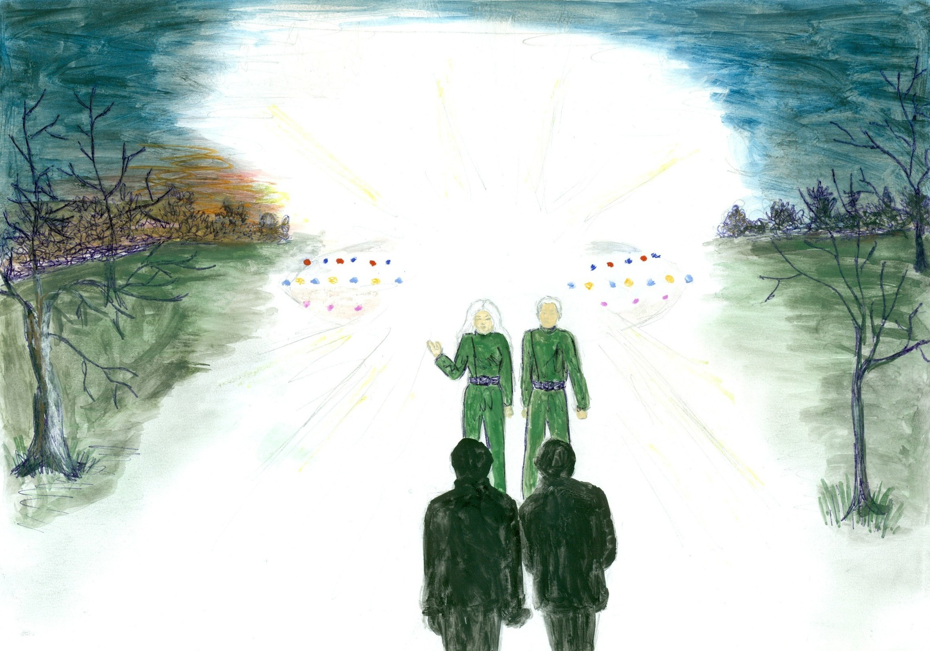
Artist's impression of the meeting. (H. Porter)

April 2012 (Update)


A short but very important update: Since the above was written, (and after a great deal of difficulty, as the area concerned is so vast), Witnesses 'H' and 'S' have managed to find the exact location where the landing took place:

(only a part of the site is shown in the right image and below)


Here is another photo, looking into the craft, and note the 'window' or screen, (at what is assumed to be the rear), with vertical lines on it; we think this might be out-of-focus tree trunks.
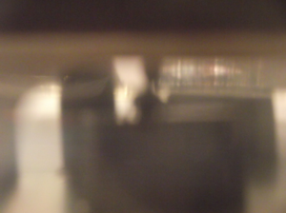

below a comparison of this window/screen and woodland.
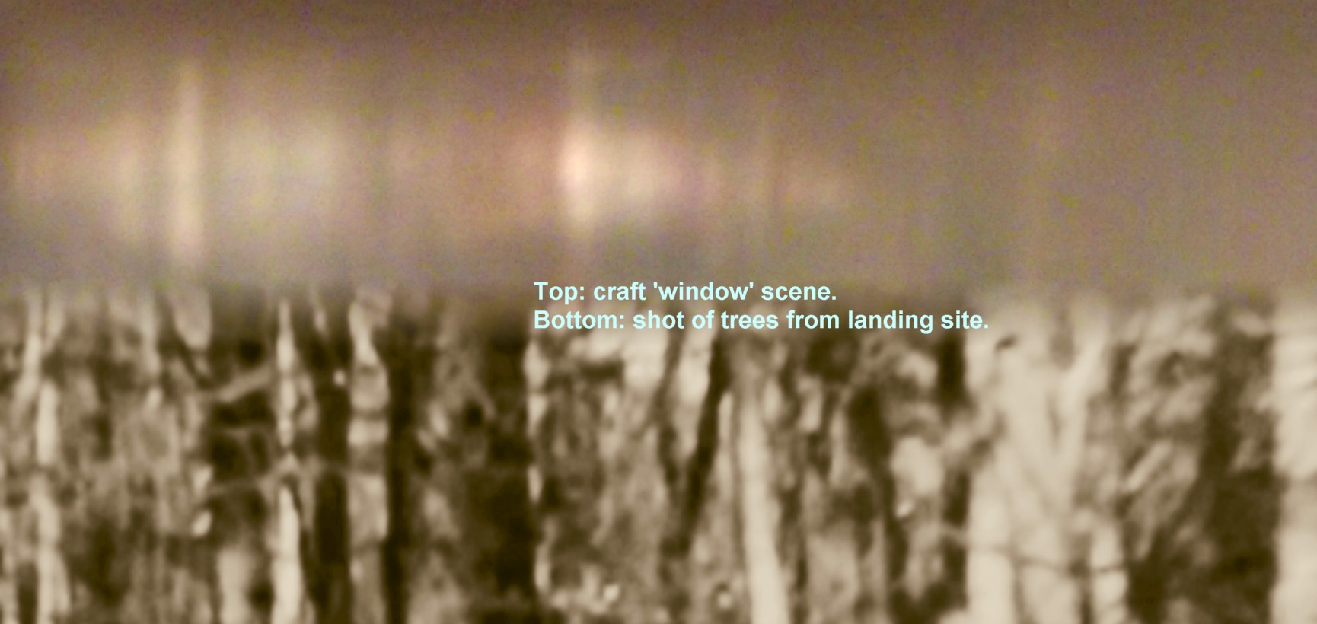

Yet, not long after visiting the site, many of 'H''s skin burns suddenly re-appeared on parts of his body, while 'S' was totally unaffected in this respect!

I have been conducting some further research about the physiological effects on witnesses to UFO events, and came across a very interesting write up.

According to Richard Neal, for decades, there have been reports of burns and rashes associated with close encounters. “Rashes are seen on the body, most appearing on the upper thorax (chest area), and lower extremities, (thighs and legs). Many are geometrical in shape, triangular or circular. Other rashes, similar to chronic inflammations, such as localized psoriasis, may be found on other body areas. First and second-degree burns have been sustained in a number of cases.”; so that statement is well worth remembering, and further bolsters our witness' evidence.

Basically, either these reactions are caused by something in the environment or they are psychosomatic, (triggered by the mind); if environmental, then one would have thought that the ground in that woodland spot might have some measurable electromagnetic contamination; but on May 20, 2012 I disproved this by taking a Geiger counter up there and didn't find anything beyond normal background radiation; although if these marks were caused by microwaves or UV, or some unknown type of energy, then this particular meter that I own would not register anything, as mine is suitable only for the measurement of Gamma and X-Rays; unfortunately, this is all I possess in the way radiation detection devices at present.

Also, 'H' recently underwent hypnotic regression, and many details emerged from those sessions.

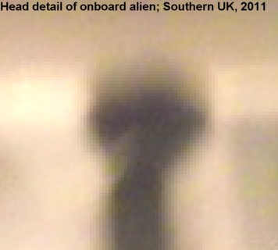
Something quite extraordinary that surfaced while he was in trance, was the information that the Nordic aliens that we hear about from encounter witnesses, are NOT at the top of the proverbial ladder as we had assumed; [how arrogant are we humans eh? to automatically assume that because they look like us, the Nordics would be superior to the other alien creatures]; no, judging from the witnesses' own experience and messages, paranormally received by them, (if correct), it is more likely that the long-necked, praying mantis-like aliens of UFOlogical legend, and as seen by 'H' and 'S' during the 'landing' event, are the ones controlling things in their world.

What you see here, (above bottom-right), is a rare, enlarged detail from a previously unpublished photo taken by 'S', which was captured as 'H' was escorted onto the craft by two Humanoid figures.

Alien information telepathically supplied to 'H' and 'S', brought forth a slightly surprising message, albeit that our subconscious thoughts can often contaminate conscious recall; apparently, these 'Mantids' are the very entities who first seeded mankind here on earth!
In truth, we are unsure whether the aliens have any hierarchical system of social organization at all, but if they do, (and with the Mantids possibly right at the top of this order), then logic suggests that the Nordic/Human-type aliens are next in line; after this may come the grays/fawns; some have conjectured that these little fellas could even be part-biological and part-robotic in make-up.

Also, 'H' revealed that he has family on board one of their craft, and that is why he broke down emotionally, at the thought that he wouldn't see his alien wife or children anymore.

Apparently, the offspring that he fathered on their ship are just like you and me, quite human in appearance.

To support this incredible case 'BEAMS' has a portfolio of other photographic material that the witnesses have amassed over a period of 1 entire year, including some truly mind-blowing images of the alien entities themselves, (with many of them surrounded by an energy aura of some kind); and as you can see from the example images shown in this book, we have interior/external shots of their craft and even an impression of some alien equipment.
These photos were 'presented' to the witnesses as a permissible opening for the world, through various photo opportunities, and a large number have already been released in the form of a double DVD presentation entitled The Best Evidence Ever?
On three occasions Witness ‘H’ has had burn patches appear over his body; possibly these were reactions from repeated proximity to these craft.

He has told me how one of them literally bathed him in hues of green, purple, red, orange and yellow, as he stood beneath it, awaiting it's next move, recording while he was able to; and he warns other investigators to be very careful of getting too close to these objects and their occupants, should the occasion arise.

On the second instance, 'H' had his burns, (which were largely on his neck, chest and arms), treated by his GP; although he refused to tell the doctor exactly what caused these wounds, as he was under the impression, (and maybe rightly so), that if one revealed the truth to their doctor that they had been abducted by aliens and taken on board a UFO, then there is a distinct possibility that they would find themselves Sectioned under the Mental Health act.
His body marks were initially examined in private by a trained medical practitioner on our team, in the presence of other BEAMS witnesses, and thoroughly cataloged photographically.

Incidentally, I personally know something about this type of 'burning', (which is in effect, I think, more of a skin irritation), as my partner Hilary, (who is an abductee herself), once had a really close encounter with a strange craft, some years before I met her.
She has often related this story to me, about how a long, wand-shaped unidentified, with a light either end, glided silently by her house one night.

As another avid sky watcher, (similar to the witnesses and myself), Hilary watched from an open upstairs window after spotting this object, as it flew by twice, turning and coming back on itself; following her study of the flyover, she was left extremely weak and barely able to crawl into bed.

In the morning she had a shock when she looked in the mirror, as she had a large red patch down one side of her face, like heavy sunburn; as with Witness 'H', the mark cleared up completely on it’s own within a few days.

Both myself and the editor of the FSR – The Flying Saucer Review, (Britain’s oldest UFO journal), have been out with these witnesses on sky watches on several occasions, and we had one really amazing sighting of a glowing red craft with them, but nothing close up; it seems while we are present, that the UFO’s will not come in quite so near for us, as for witnesses ‘H’ and ‘S’, (not yet anyway), so we will continue to try and earn the alien’s trust.

Aside from the excellent red craft sighting, there have definitely been what I would describe as paranormal instances whilst out in their company as well,... numerous very odd happenings which defy logical explanation.

Beyond Defence Significance/Summary Conclusions

The MoD's official stance on UFO's is that they are of “no defence significance”; yet, if these objects aren't a security threat, as in terms of their unknown intentions,...
then it makes one wonder what is:

For example, in 1964, an officer in charge of optical instrumentation at Vandenberg Air Force base in California, whose job it was to film ballistic missile tests, caught on film, a UFO traveling right next to a missile during it's launch: He says the mystery object resembled two saucers cupped together with a round ping-pong ball-like surface on top.

The film showed that from the ball, a beam of light was directed at the missile.

It is obvious that they are deliberately playing dumb; the military heads definitely know much more than they are letting on.

Make no mistake, this subject goes way beyond such ridiculous mantras as of “no defence significance”; truth is, the existence of aliens remains a carefully guarded secret by those who control the reins of power on earth; and any positive contact that can be made with these races should be considered as the greatest, and most important event ever to have taken place in the history of mankind.

In summary, (based on messages channeled from 'them' to us by Witness 'H', and from our own observations), we have learned that:

The known alien protagonists of this case, (those seen firsthand by Witnesses 'H' & 'S'), consist of three kinds of species-related being, of differing sizes and varieties: but there are rumored to be others 'types', (good and bad), as well, which we haven't yet come across.

From witness encounter statements, together with what we have seen through obtained digital images, 'their' pecking order goes something like this: The tall mantis creatures are probably the controllers, next come the Humanoids or Nordics, who may be deployed as scientists, diplomats, (of sorts), and scouts.

Last, but not least, there are the grays/or EBE's.

The grays/EBE's are the medium/smaller-sized creatures; they have large eyes, and no hair; they come across as quite intelligent but seem to lack logic and emotion; some 'types' may be able to change the color of their skin according to the environment they are in; the likelihood is that these are manual workers,... someone/something programmed to do a set task by all accounts.

One thing in common between the aliens, is that they all communicate telepathically.

The visitors are inter or multi-dimensional travelers, and they come here to harvest genetic material and possibly also, to help mankind through the danger we face in coming years.

Their journey here to the earth plane is done with ease, through the use of sophisticated technology; they arrive quite literally, from their world to ours, through surrounding space, as opposed to outer space.
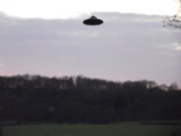
Most of the craft we see are able to manifest in a variety of shapes, forms and hues according to their requirements; eg: they may want to be discretely camouflaged against clouds or a blue sky, or even to purposely make themselves visible, such as putting on an inviting display of color for certain witnesses.

The hulls of the UFO’s are ‘living’ or organic, rather than of a rigid nuts-and-bolts construction.

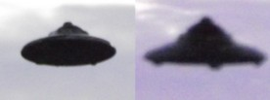
The different classes of craft include gigantic mother ships, which are like cities and can accommodate thousands; next are scout craft, piloted by one or two aliens at a time, and finally there are remotely controlled probes. None of these vehicles make much of a sound if any, (to our hearing range anyway), except perhaps for a light humming noise on rare occasions.

Above and below are shots from West Sussex, UK, 2012.
Top is an original; bottom are two cropped stills from the event, enlarged and stitched together, showing the craft from slightly different angles.

The resulting images didn't come out on camera quite as Witness 'S' saw the craft in real time so to speak; he described what he watched as “bronze in colour, with a series of coloured lights on it's underside; something which was “beautiful”, to quote him; but these captures are most interesting because they show quite a bit of structural detail.

The race who control these objects will not appear publicly; they fear and distrust human beings immensely, and it is my opinion that only certain people are selected for the task of meeting them; very few qualify.

They know we are basically a warring species and that man's deceptions are dark,... his promises often false; this is why they are most distrustful of us and our elected leaders, hence their preference for meeting and liaising with specific, ordinary individuals.

I am sure that the visitors closely study our behavioral and quality patterns very carefully in order to find just the right people for their purposes.

Special attention seems to be paid to subjects from certain genealogical backgrounds; those who are kind and have a strong, spiritual nature, and those willing to put themselves out the most,... and willing to make personal sacrifices in order to see/contact the beings,... such as through regular sky watching: They're looking for the ones who are willing to go just that extra mile,... often quite literally! Devotion to the cause.
What other prime requisites are there? Well, I have noticed a patient, humble and compliant disposition in the witnesses: and aside from such meekness, a further benefit in chosen individuals would be to possess the mental capability to cope with mental and physical trauma,... as so often left by these close encounters:

This stringent level of focus by the aliens, regarding as to how contactees are selected, means that the chances of this happening to a person must be many thousands-to-one.

In all my experience as an investigator, I can say with confidence that totally genuine alien contactees like Witness 'H' & 'S', are very few and far between.

Orchestrated Mind Control

Make no mistake, the visitors can telepathically control individuals who have been picked for their purposes, very easily.

The instances where both 'H' and 'S' have been psychically guided into going to certain places, at a specific time, by the aliens, in order that they may observe UFO activity, or even, (as I have already touched on), be abducted, or rarest of all, to watch their vehicles in a landed situation, even interact with the aliens, are many fold.

Even those around them can fall victim to such control,... I can testify to that.
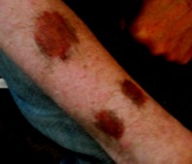
The humanoids and their associates are certainly not all peace and love, far from it; they can be quite ruthless to get what they want,... psychically and mentally affecting witnesses in the process.

This often results in either temporary or long-lasting physiological injuries, both internally and externally; including operation scars, and burns, bruises and scratches, and mental health issues.

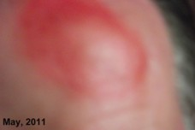
One night in May of 2012, 'H' experienced a bedroom alien visitation: This image to the right shows marks that he received during the incident: I have had pictures of his injuries properly looked at using high magnification techniques, and through this, one can see that the wounds were quite deep in places, where the stratum corneum, (the outermost skin layer), had been removed to reveal lower layers of the epidermis.

Although the images can't all be shown to preserve this guy's real identity, other pictures also reveal blackening beneath his eyes, reddening of his facial skin and scratches to his back; with similarities to, but far worse than, a previous abduction incident in 2011, (at Dragon Hill, Oxfordshire), where he received only superficial reddened, inflamed skin, (but not blistered), scratches on his back, probably resulting from being dragged along the ground.

After the 2012 bedroom incident, 'H' literally stayed indoors for weeks, deeply embarrassed to step outside, in fear of what others might think about his appearance.

Abduction: How it happens

'H' said that he was visited in the night by some small beings who were led by a taller figure; they 'came' through his bedroom window.

'H' steadfastly refused to go with them; there was quite a struggle, and the dark red/black marks on his arm are largely the result of his resistance to the abduction: Despite putting up a fight, 'H' was still taken though. Photo above right shows a burn on the forehead of Witness 'H', taken in May, 2011.

Skeptics have always used the same old chestnut about alien abductions; they usually present their argument along these lines: how on earth could this be achieved by alien intruders without anyone else seeing? where are the witnesses to these events? Surely, with all of the reports about abduction that there are, one would have thought that by now, an eyewitness somewhere, would have captured smoking gun evidence of this on their camera phone: of a body levitating out of a window perhaps, on a beam of light to a waiting craft; so come on, where is it then?

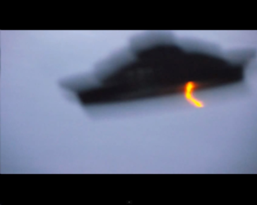
One answer to this type of narrow-minded reasoning, is that feasibly, the aliens do not always abduct a person in the flesh, but rather, they have the ability to take an individual molecularly, through molecular trans-location,... a process of dematerialization and materialization; exactly the same 'trick' that we know for sure, their vehicles perform on a regular basis,.. as these H & S craft images show: Note the elongation, shape-shifting, multidimensional aspects.
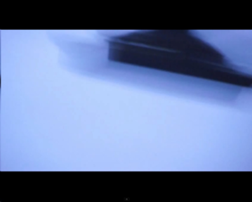
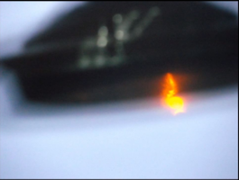
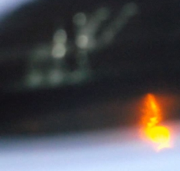

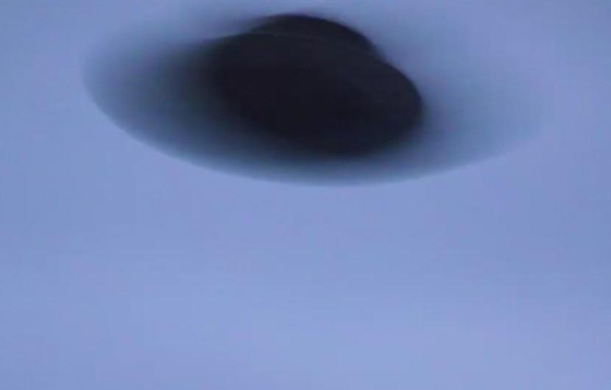
Indeed on one particular sky watching expedition that we took with our witnesses, I saw 'H' himself, undergo a similar, possibly related process...a type of mental transfiguration; this is where his whole personality changed as he was temporarily taken over by a dark spirit entity that wanted to speak through him,... which it did, warning us to leave the woods we were in.

During the episode 'H' became violent and started speaking in a strange voice: Despite the shape-shifting changes NOT being visible to our eyes at the time, my pocket camera caught this possible energy anomaly to his head area; see right:
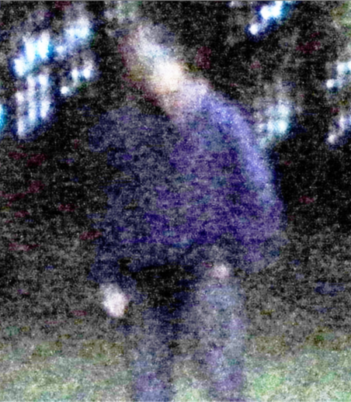
Surgical operations may be performed by the aliens on abductee victims; worldwide reports include accounts about the removal of eggs from women, (sometimes resulting in permanent fertility problems), and in males, their sperm is extracted; skin and blood samples can be also taken.

Just an idea: Could it be that ultimately, these creatures consider man's inner spirit counterpart, (also called the astral energy, life force, soul or aura), to be of more significance to his well being, than the flesh- and-blood body? That it doesn't matter too much whether his genetic “shell” is experimented on and has samples removed, and/or is subjected to the occasional rough bit of handling? especially if one tries to resist.

To our human logic, all of this may come across as quite brutal, but that's just it, we tend to think and act ONLY according the sets of human moral standards taught to us; behavioral codes and teachings which are instilled in us from an early age, and unwritten rules of common decency picked up throughout life; whereas the visitors have no such formula to work by. Imagine how they must see the human race and how we behave; how for instance, we daily treat thousands of livestock in slaughterhouses; they may view us as having very little respect for life; so why should the visitors treat us any differently?

Yet thankfully, they DO usually show a tolerable degree of compassion towards abductees.

For all we know, the human race may be little more than an exercise in genetic research and development; and abductees are the aliens' control samples,... lab animals, pets even; they may re-visit this earthly laboratory at various periods to check and see how their venture is faring.

The aliens we have come to know something about, cannot be oblivious to mans' ineptitude, especially when it comes to global management of his planetary resources, and unless they want us to self-destruct for some perverse reason, then surely their desire would be that we reverse the situation rapidly.

So, for us, this is The Last Chance Motel; 'they' are fully aware that mankind has mucked up big time as far as the planet is concerned, and from from where we stand, and probably from the aliens' perspective too, if we fail to turn things around, then as a species, we are finished.

Mind Programming:

I'm sure that our world leaders are fully aware of these entities and said activities, and that certain psychological tactics are being employed to stop the truth getting through to the public.

This is done is several ways, but most commonly through altering people's perception of reality, by encouraging media distractions to keep the average persons' mind as busy as possible.

They say that TV is our greatest mentor, and let's face it, many, (probably the greater majority), are addicted to that box/panel set in the corner their lounge, and now in HD, even 3D as well!

Is it any coincidence that daily we are served a TV diet, full of meaningless, mind-contaminating pap; such as TV reality/game shows; and no offense to sports fans here, but it goes without saying really, that sports news coverage conveniently occupies a good portion of our life; then there is deliberate misinformation, (such as a proliferation of hoaxed UFO material on the net and elsewhere), and the blatant ridicule that is put out in the media about our topic.
Another favorite mind programming tool of our controllers, is to manipulate us through threat, worry and reward:

Encouraging debt is an ingenious artifice, keeping us constantly enslaved to the banking system; fear of mortality is another ploy, which is ingeniously achieved by showing a consistent barrage of medical stories, health scares and that type of thing; and at the other end of the scale, they give us the feelgood factor,... our reward, our escape route.

It doesn't end there either; through the use of some clever screening/coverage, the TV stations actively promote vanity, such as cosmetic surgery, beauty product advertising, fashion and holidaying: Even alcohol consumption is being peddled and glamourized on television,... and in film to a degree, along with other forms of drug abuse.

You see, it's all about control: What I am discussing here are Trojan Horses, 'hidden' in programmes, yet which are staring you in the face, (often the best way of hiding something); suggestions, (sometimes almost at a subliminal level), which are usually passengers in the vehicle of high-audience soap dramas, with the message that they wish to convey cleverly incorporated into specific storylines etc, etc;

These same brain occupying/persuasion techniques, are found in many other categories of broadcast and entertainment also, the biggest culprits of which are the video gaming and gambling industries.

This is one of the reasons why, (if by a million-to-one chance), a genuine example of alien contact with humans is recorded, as with H & S, then only a small number will ever get hear about it, and of those who do, fewer still will take any notice.

Basically, we have all been psychologically instructed through media mind manipulation, NOT to believe,.... the trick is to disobey our controllers commands.

I started by out saying at the beginning of this 'Diary', that little else in UFOlogy compares to the case that I have outlined here:

Why put up with the dubious when we have the undoubted?

Whether it is the visitors intention or not, spreading the word about all of this, as far and wide as we are able, is surely the right thing to do; and you the reader, can help by telling others too.

Kenneth John Parsons
(BEAMS Chairman)
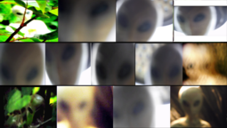
A few Extras:

The alien images that H & S have captured on camera so far.
------------------------------------------------------------------------------------------------------------
An email that I received from 'H' concerning his decision to move to Oxford.

Hi Ken

I just had a phone call from ****, (S), and he told me that BEAMS had been getting some menacing emails about my UFO experiences.

I really am sorry to hear this as ****, (S), and his wife, who are very dear friends of mine, had also been receiving lots of anonymous emails, some of which were very threatening and personal, that is why I moved up to Oxford to deflect attention away from them, because I felt that this was all my fault; if I didn't have these UFO experiences, none of this would have happened to either of you.

****, (S), told me not to worry, I was not to blame, which was very gracious of him, but I still feel responsible for all of the trouble that has resulted from this.

I'm very sorry this as happened to you both.

Signed *****(H)
One example of a positive feedback about this case:

Dear Sirs

I have encountered these beings multiple times at night, but always after being taken from my room, however I don’t have proof.

It's outstanding that you have actual pictures: I am near tears because of what this represents on so many levels.

The main creature I have seen is about 5' 5"-6' feet tall; I'm 5' 9" and he is about same as me; then there is also a short white that visits me very often, but he is more like 4 to 5ft tall, very child-like in stature, (a bit like a 9 year old, one of the typical white/grays), with super-white skin, almost normal, human-build, beautiful, small facial features, and those big eyes.

I have many conscious recalls of beings like this, then also I have been hypnotically regressed by Joe Montaldo with voice stress analysis, and we identified one particular one like this that I adore, which has been in my life since my early childhood.

In regression I saw 2/3 slightly different appearances he takes to appear to me; likely this is just a mental projection into my mind. One is bald with the big eyes; one is same white skin, same body build, but with white hair, sleeked-back and beautiful big pale blue eyes, skin like snow, always wearing white.

To me it seems the same or very very similar beings as on pictures, but I could be wrong of course.

Anyways

You guys are doing fantastic work!!

Take care...

&

Tell H & S I say hello.

